Title: Thank You for Celebrating PEOPLElogy’s 25th Anniversary With Us
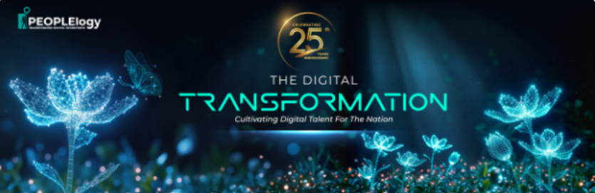
Dear Valued Guest,
On behalf of everyone at PEOPLElogy Berhad, thank you for joining us at our 25th Anniversary Celebration.
Your presence made this milestone truly meaningful. As we reflected on the past 25 years of growth, innovation, and partnerships, we were reminded that our journey would not have been possible without the support of individuals and organizations like yours.
We hope you enjoyed the evening’s celebrations, conversations, and opportunities to reconnect with fellow industry leaders, partners, clients, and friends.

Event Photo Gallery
We’re delighted to share a special keepsake from the event. To receive your event photo, please click the link below and scan your face. Our system will securely identify and retrieve photos featuring you from the celebration. Relive the memorable moments from the celebration through our event photo gallery:
📸 View Event Photos Here:
[https://harimau.run/peoplelogy26]

Discover Your AI Readiness
As we look towards the future, we invite you to take the next step in understanding your organisation's preparedness for the age of AI.
Our complimentary IMAIREADY AI Readiness Assessment provides valuable insights into your organisation’s current AI maturity, opportunities for growth, and areas for development.
🤖 Take the IMAIREADY AI Readiness Assessment:
[https://imaiready.asia]
Once again, thank you for being part of this special milestone. We look forward to continuing our journey together as we build the future of work, leadership, and workforce transformation.
Warmest regards,
PEOPLElogy Berhad

